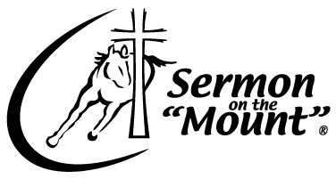
35102 County Street 2740, Anadarko, OK 73005
★ 405-453-7686
www.SermonOnTheMount.org

Host Application

Applicant’s Name:
Address:
City: |  |  |  |  |  | State: |  |  | Zip:
Home Phone: |  |  |  |  |  |  | Cell Phone:
Work Phone: |  |  |  |  |  |  | Fax Number:
Email:

Please view the Sermon on the Mount® Host Requirements and Event Possibilities (downloadable at www.SermonOnTheMount.org) to understand what is involved.

- Sermon On The Mount
- Leaders by H.E.A.R.T.
- Motivational Speaking
- Men’s Seminar – Stud Talk
- Marriage Seminar – Dynamic Oneness

What is your preferred time of the year that you would like to host an event?

Preferred Dates:

Are these dates flexible?  YES  NO

Have you hosted a Sermon on the Mount® or other large event before?  YES  NO

Describe the audience that would be attending: (church, school, college, horse groups, etc.)

How many people are you hoping to have at the event?

Where would you host the presentation? You must be able to house 2 stallions (call for requirements).

- Arena (indoor*/outdoor)?  - Business  - Fairgrounds | - Lawn  - Ballfield  - Other_____________________________________

*Indoor arena is preferred for reasons of weather

What organizations would be hosting and co-hosting this event? (5 or more are requested)
1.
2.
3.
4.
5.
6.
7.

What volunteers will commit to help at this event? (5 other or more are requested)

Name |  | Type of Help (promotion, raise support, obtain horses, etc.)
1.
2.
3.
4.
5.

Please include any other details about the event that you might have. This is very helpful in determining our ability to give a presentation in your location.

What questions do you have for us at this time?

Prices range from $3,500 – 10,000 based on the time commitment of the event. For questions concerning availability and price, please call our office and request to speak to our event coordinator.

Please feel free to contact us by phone and/or email at any time.

Please send to:
Sermon on the Mount®,35102 County St. 2740, Anadarko, OK 73005
Attn: Sandra Sterrett, Event Coordinator or email to: sandradclick@gmail.com

